Observation List
VStar’s observation list is selected via the Observations tab in the main window and consists of a tabular view of the loaded observations and a Search Creation pane.

The following shows the observations list with eta Aql observations loaded from AID.

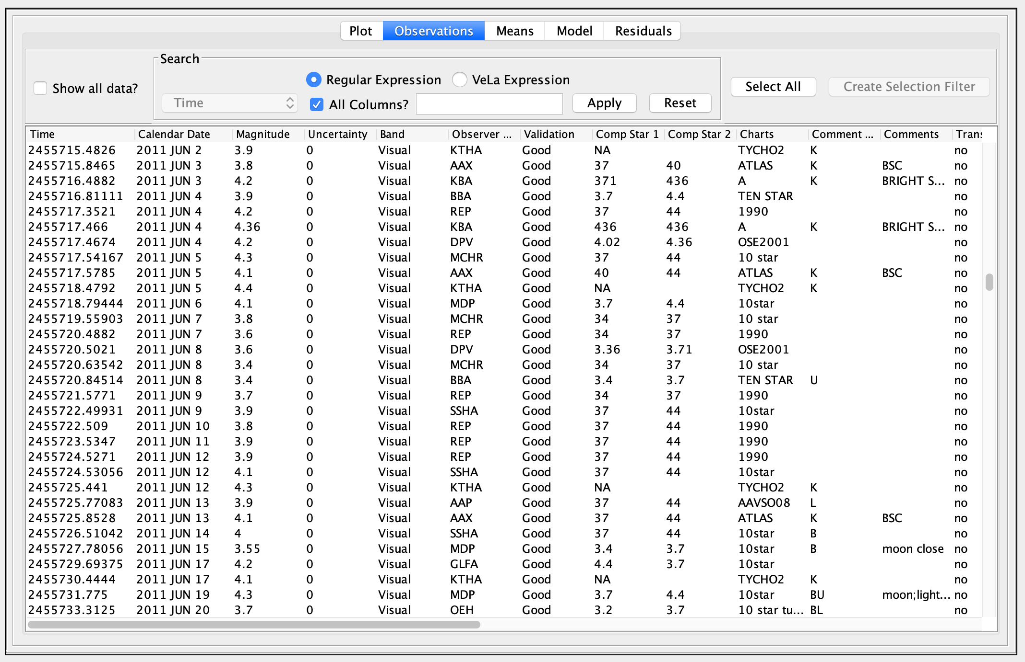
The most obvious feature is the tabular list of observations consisting of columns relating to each observation, e.g. Magnitude, Band, Comp Star 1. The figure shows a row having been selected by the user. Switching to the Plot tab would reveal that the cross-hair was pointing to the same observation in the light curve or phase plot.

Columns can be rearranged by dragging the column headers, and observations can be sorted by column by single-clicking on the column header. In any mode (raw or phase plot), the default is for observations to be sorted by Julian Date.

The set of columns that appear in the observation list varies with the observation source (e.g. AID, files of particular type).

Something not obvious at first glance is that the observation list mirrors the plot. In other words, if a particular band/series is visible on the plot, it will also be visible in the observation list. It is possible to override this by selecting the Show all data? checkbox. Note this will not affect the plot. The same is true for the Search feature. Selecting the Regular Expression radio button (selected by default) and typing a regular expression into the text box to the left of the Apply button, followed by clicking that button will:

- Look for a match across values in all columns.
- Filter the list based upon the match.

If no match is found, no observations will be displayed. Clicking the Reset button will restore the normal observation list. Note that when Show all data? is selected, the Search pane is disabled.

The following shows a pattern search for the word “moon”, resulting in a listing that consists only of observations in which the word “moon” appears somewhere, specifically: in the Comments column. In this example, the comments column needs to be expanded to see some occurrences of the pattern, e.g. those near the middle beginning with “Clear. Wa...” when expanded, show “Clear. Waxing moon.”

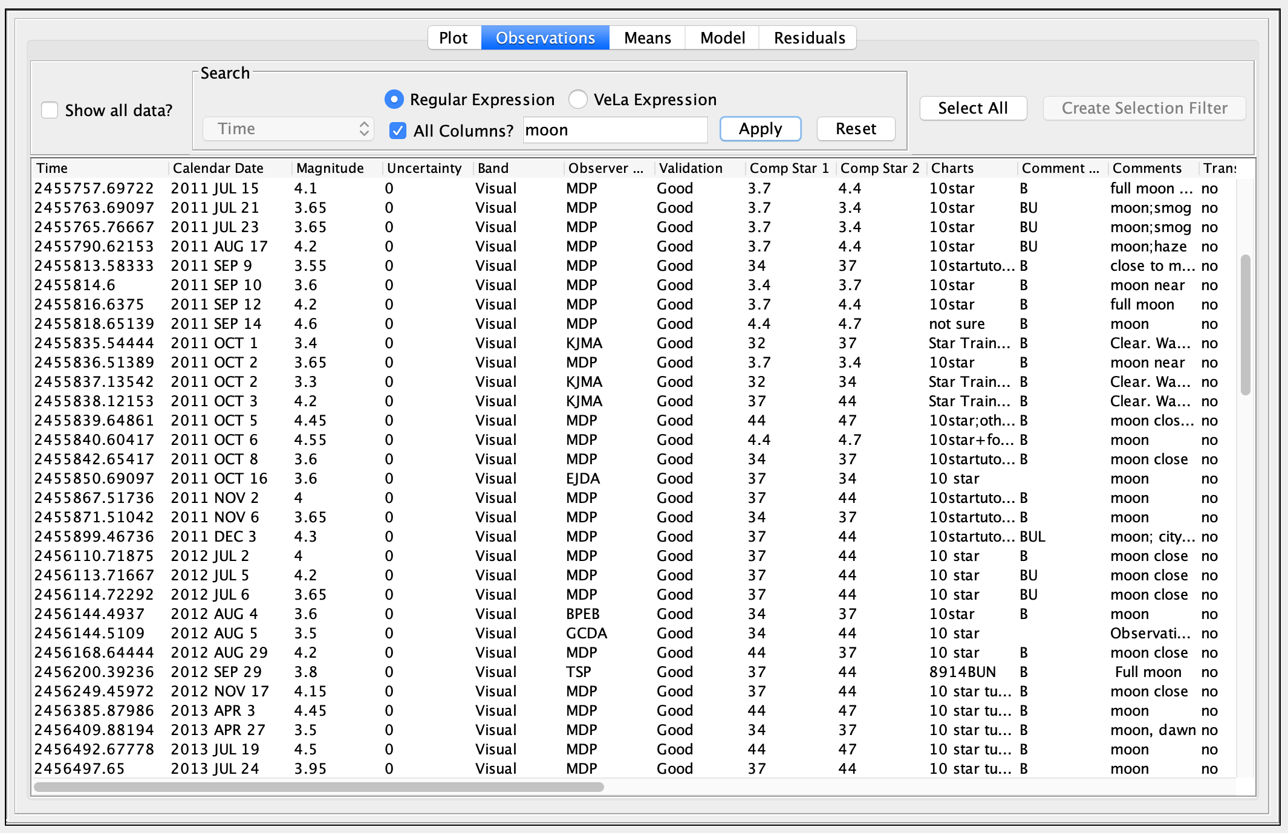
Rather than asking VStar to match across all columns, a particular column can be targeted, as in the following example that looks for observations whose Calendar Date column matches “2011 OCT 31” or “2013 APR 23” via the pattern 2011 OCT 31|2013 APR 23 where the vertical bar character (“|”) means “or” or “alternatively”.

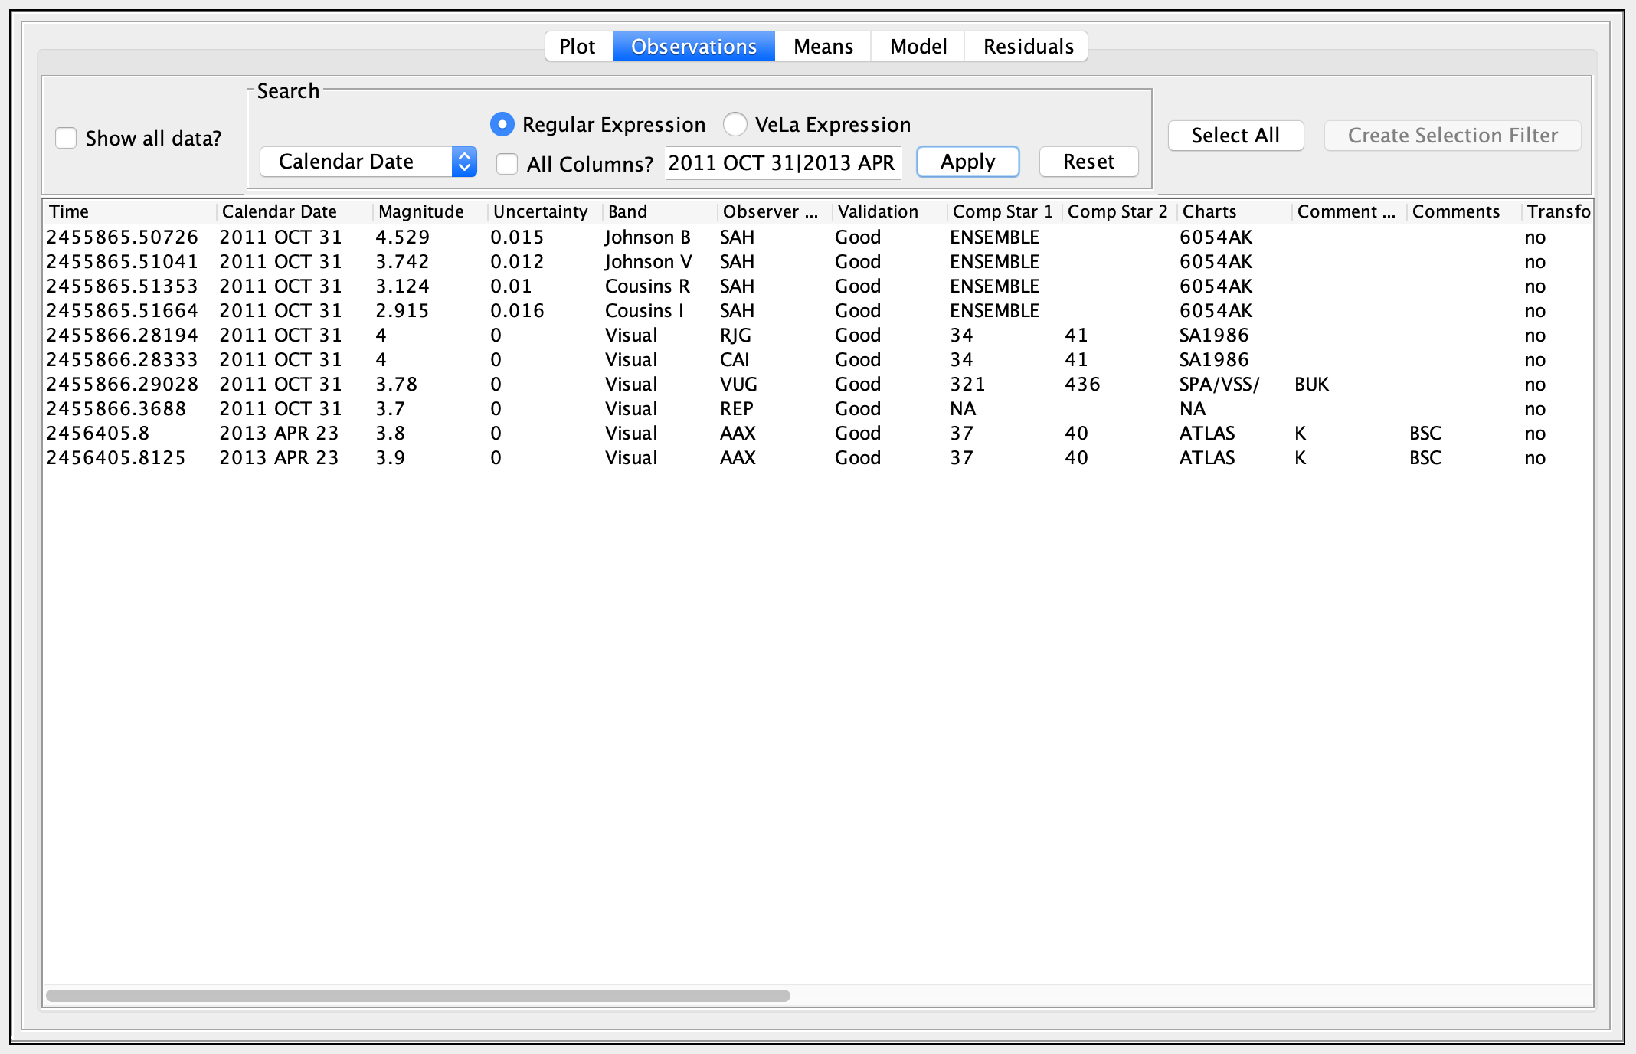
The following shows the result of applying the pattern ^\d{2}$ to the Comp Star 2 column so that only those observations whose second comparison star consists of 2 digits will be shown:

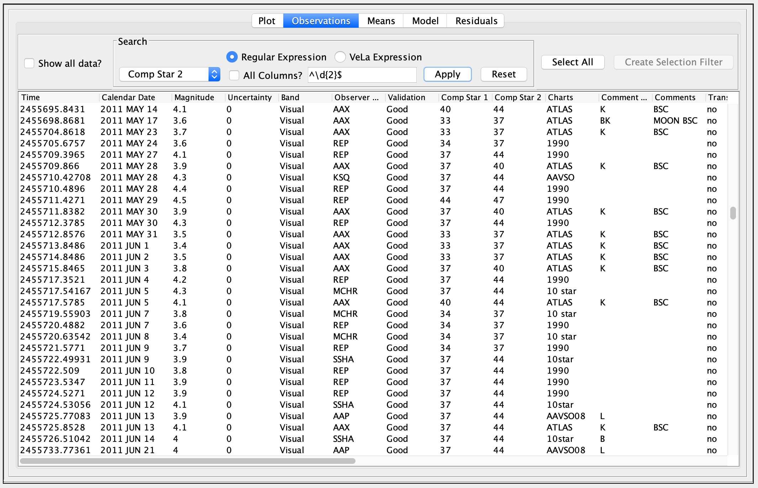
The caret (“^”) means “start of string”, dollar (“$”) means “end of string”, “\d” means decimal digit characters (0 to 9), “{2}” means two of those (digit characters). This reduces to: “comp star 2 must only consist of 2 decimal digits to be included in the observation list.”

Regular expressions can be simple strings or extremely complex patterns, but a VStar user need not be troubled by using anything more complex than he or she requires.

A complete treatment of regular expressions is beyond the scope of this document. See Regular Expressions subsection in References and Further Reading.

A search will disrupt the synchronization between plot and list, as will clicking the Reset button.

There is a second radio button in the Search pane: VeLa Expression. Selecting this allows a VeLa expression to be entered. The following example shows the results of a VeLa based search for only those V or B and CCD or DSLR observations with a magnitude of more than 3.7 an uncertainty of less than 0.02:

mag > 3.7 and uncertainty < 0.02 and
band in ["Johnson V" "Johnson B"] and
obstype in ["CCD" "DSLR"]

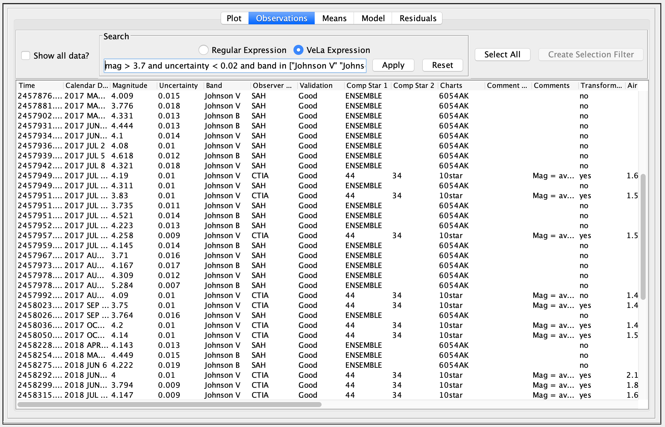
See also Filtering Observations.

If one or more observations are selected in the list by single-clicking, shift-clicking, or ctrl-clicking, those observations may:
- be excluded via Edit → Exclude Selection;
- form the basis of an observation filter via the Create Selection Filter button. See the Filtering Observations section for more information.

Note that the Select All button is useful for selecting all observations currently in view in order to create a selection filter or exclude observations.

Each Observation List row also contains a Discrepant? checkbox indicating whether an observation is “discrepant” and permitting an observation to be reported as discrepant. See the Observation Details Dialog section for details.

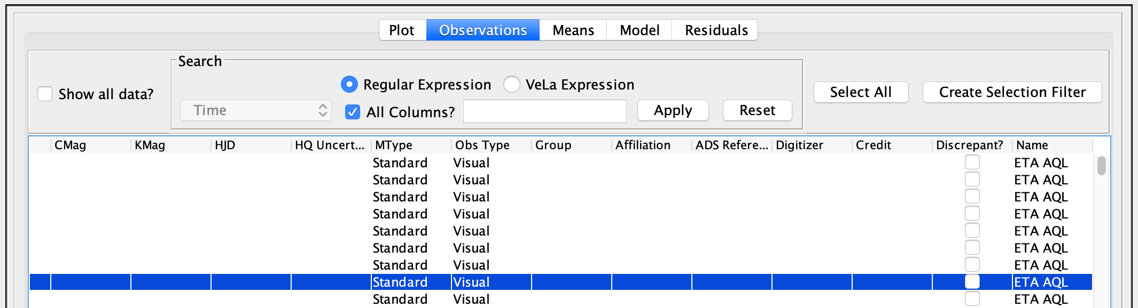
The contents of the Observation List can be saved to a text file or printed via the File menu’s Save... and Print... items, or the corresponding toolbar buttons.

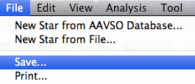
An example of the Save Dialog is shown below.

In the example above, when the Save button is clicked, the current Observation List will be saved to a file called “omiCetLC.tsv”.

Files can be saved as rows of tab, comma, or space separated values. The first two are preferable over the latter since spaces in some fields lead to ambiguity if loading back into VStar or other software is required. From experience, tabs are less frequent, compared to commas, in fields such as comments (as found in AAVSO download files), so tab separation is a good choice.

The file created when saving observations is in the download format. To reload it into VStar at a later time, just use New Star from File… You might find it useful after doing additive loads from several sources to save the set of observations to a file for future work. Be sure to make sure the set of observations you want to save are in the observations list. Only these will be saved.

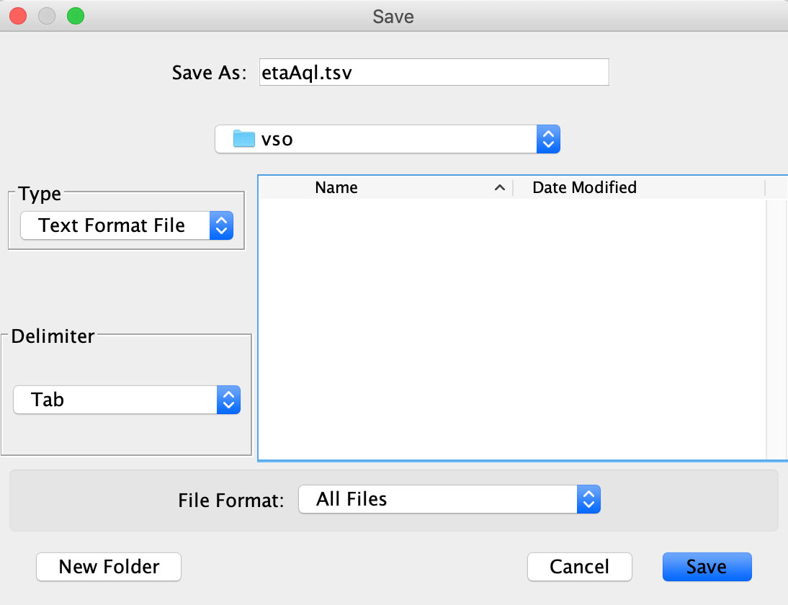
The Print Dialog looks like this on a Mac OS X machine:

